Title (Bold, Arial 12, centered)

Presenting Author,ª co-autor,^{b} Corresponding Author*ª (Bold, Arial 9)
a) Department, University, Address, ZIP code, Country.
b) Department, University, Address, ZIP code, Country. (Italic, Arial 8)

Abstract, Arial 8, Line spacing 1.0, justified. Abstract, Arial 8, Line spacing 1.0, justified. Abstract, Arial 8, Line spacing 1.0, justified. Abstract, Arial 8, Line spacing 1.0, justified. Abstract, Arial 8, Line spacing 1.0, justified. Abstract, Arial 8, Line spacing 1.0, justified. Abstract, Arial 8, Line spacing 1.0, justified. Abstract, Arial 8, Line spacing 1.0, justified. Abstract, Arial 8, Line spacing 1.0, justified. Abstract, Arial 8, Line spacing 1.0, justified. Abstract, Arial 8, Line spacing 1.0, justified. Abstract, Arial 8, Line spacing 1.0, justified. Abstract, Arial 8, Line spacing 1.0, justified. Abstract, Arial 8, Line spacing 1.0, justified. Abstract, Arial 8, Line spacing 1.0, justified. Abstract, Arial 8, Line spacing 1.0, justified. Abstract, Arial 8, Line spacing 1.0, justified. Abstract, Arial 8, Line spacing 1.0, justified. Abstract, Arial 8, Line spacing 1.0, justified. Abstract, Arial 8, Line spacing 1.0, justified. Abstract, Arial 8, Line spacing 1.0, justified. Abstract, Arial 8, Line spacing 1.0, justified. Abstract, Arial 8, Line spacing 1.0, justified. Abstract, Arial 8, Line spacing 1.0, justified.¹⁻³

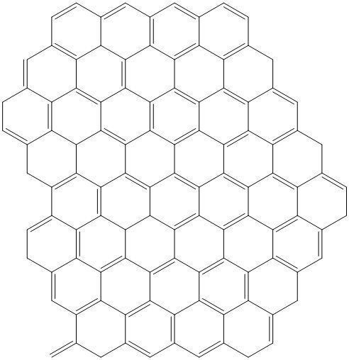
Figure 1. Caption (Arial 8, centered).
References
1. Authors, Journal. year, Volume, initial page
2. Authors, Journal. year, Volume, initial page
3. Authors, Journal. year, Volume, initial page

